***3D Sand Painting***

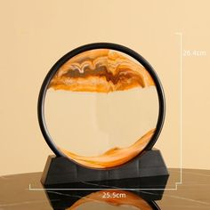

*There are many colors to choose from: blue, green, pink and purple. You can create as many pictures as you like. (See detailed product description below for product understanding). The product is suitable as a gift for boyfriend, girlfriend, friends, colleagues,*